Database Scenario
You are developing a database for a company called TechNova Solutions.
The company has two tables:
- Departments
- Employees
Employees belong to different departments, and the management wants various analytical reports using Subqueries.

Create the Tables
Create the following tables:
departments
Column | Data Type
id | INT
department_name | VARCHAR(50)
location | VARCHAR(50)
create table departments(
id int primary key,
department_name varchar(50),
location varchar(50));
insert into departments values
(1,'Engineering','Hyderabad'),
(2,'Sales','Bangalore'),
(3,'HR','Hyderabad'),
(4,'Finance','Chennai')
;

employees
Column | Data Type
id | INT
name | VARCHAR(50)
salary | DECIMAL(10,2)
department_id | INT
Use appropriate PRIMARY KEY and FOREIGN KEY constraints.
Insert:
- At least 4 Departments
- At least 10 Employees
Make sure:
- Multiple employees belong to the same department.
- Different departments have different average salaries.
- At least two departments are in the same city.
create table employees(
id int primary key,
name varchar(50),
salary decimal(10,2),
department_id int,
foreign key(department_id) references departments(id)
);
insert into employees values
(101,'Dinesh',80000,1),
(102,'Akhila',68000,2),
(103,'Sushma',65000,1),
(104,'Anitha',75000,2),
(105,'Kalyan',85000,3),
(106,'Babu',35000,4),
(107,'Vignesh',40000,4),
(108,'Siddhu',81000,2),
(109,'Bob',90000,1),
(110,'Pavan',82000,3)
;

Section A – Scalar Subqueries
Use only Scalar Subqueries.

1.
Display employees earning more than the company average salary.
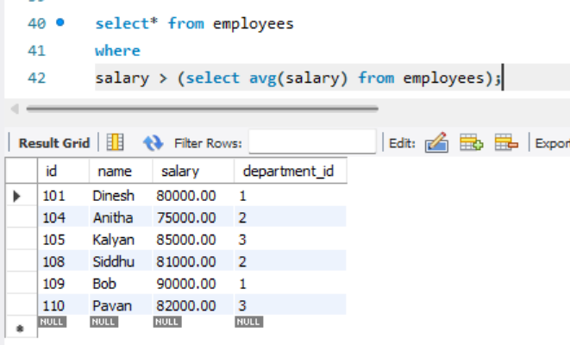

2.
Display the employee(s) earning the highest salary.
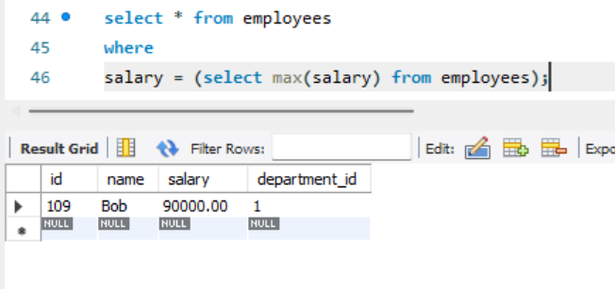

3.
Display the employee(s) earning the lowest salary.
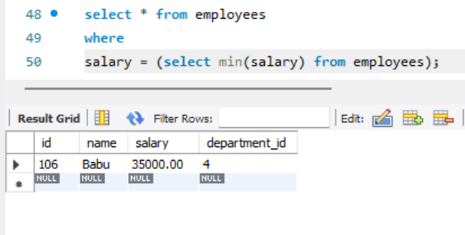

4.
Display employees earning more than the minimum salary.
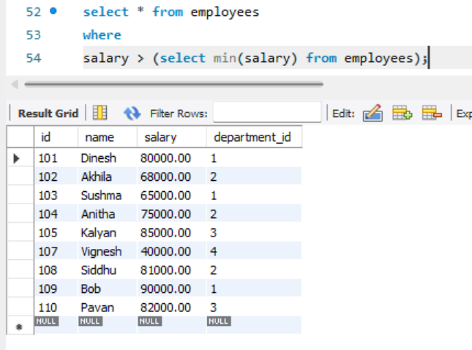

5.
Display employees earning less than the highest salary.
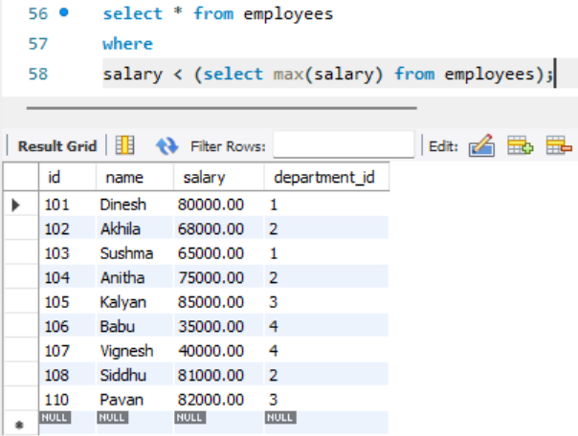

6.
Display employees earning exactly the average salary.
Observe the output.
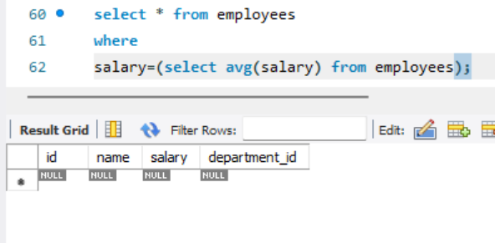

7.
Display employees earning greater than the average salary but less than the highest salary.
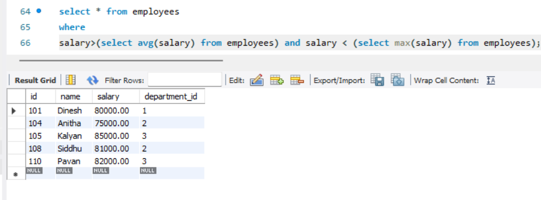

8.
Display employees earning less than the company average but greater than the minimum salary.
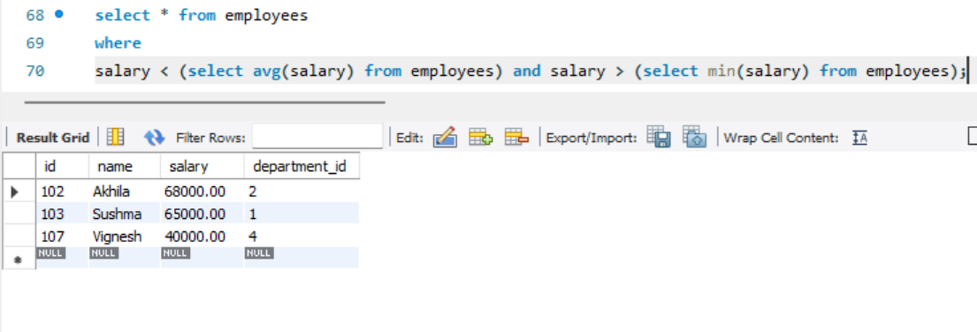

9.
Find employees earning exactly the maximum salary.
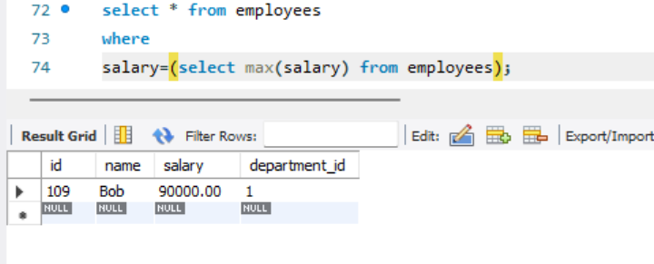

10.
Find employees earning exactly the minimum salary.
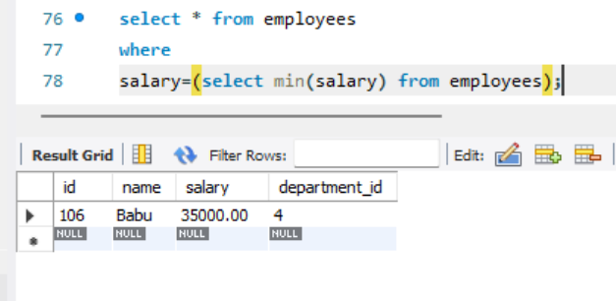

Section B – Multi-row Subqueries
Use only Multi-row Subqueries with the IN operator.

11.
Display employees working in Hyderabad departments.
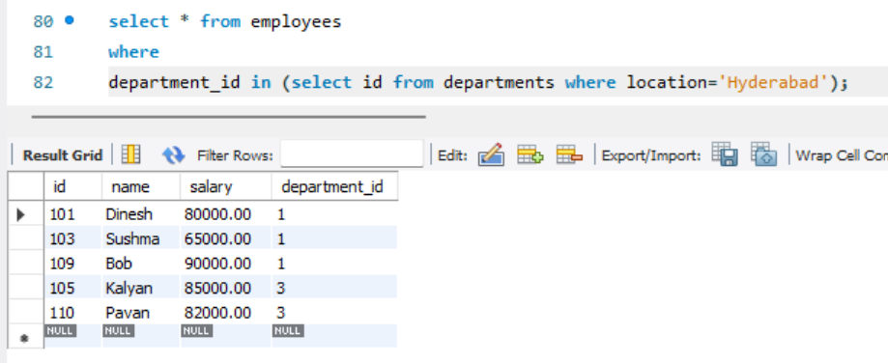
12.
Display employees working in Bangalore departments.
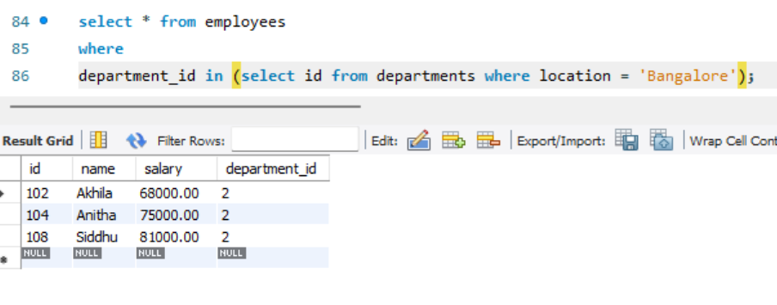

13.
Display employees working in Chennai departments.
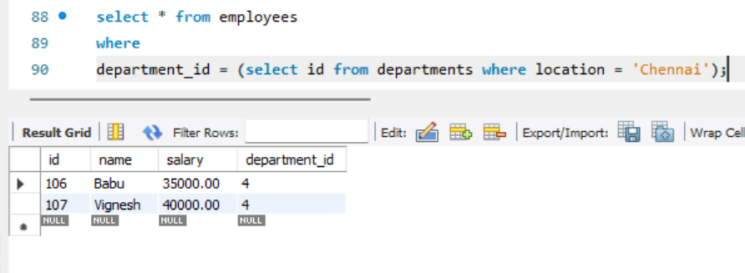

14.
Display employees working in Engineering or Sales departments.
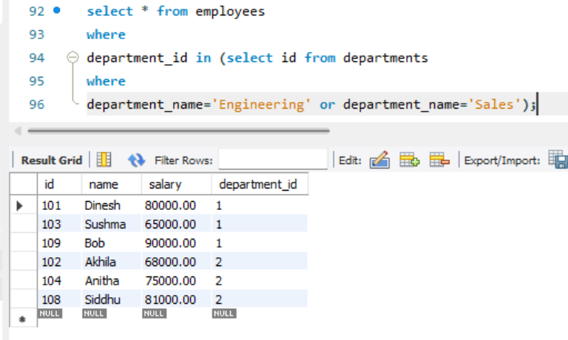

15.
Display employees belonging to departments whose ID is greater than 2.
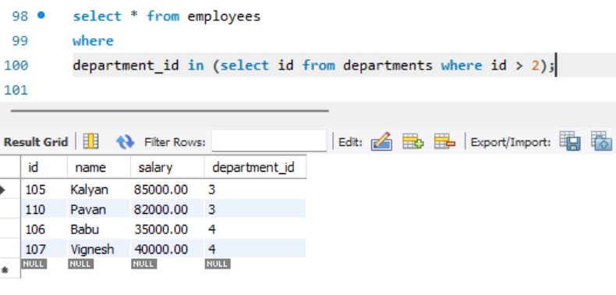

16.
Display employees belonging to departments located in Hyderabad or Chennai.
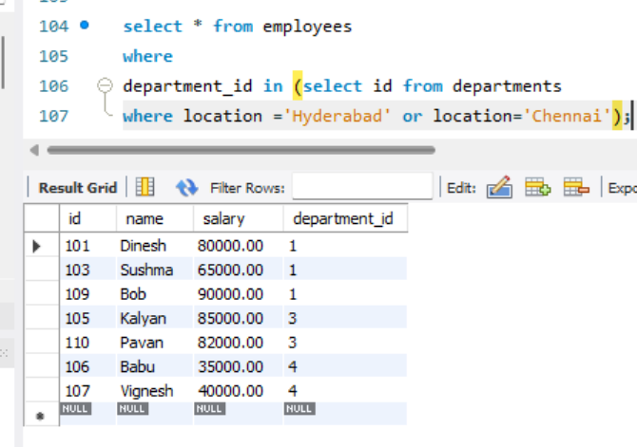

17.
Display employees working in departments whose names start with the letter S.
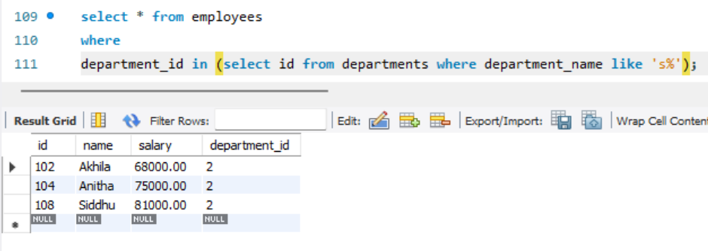

18.
Display employees working in departments located outside Bangalore.
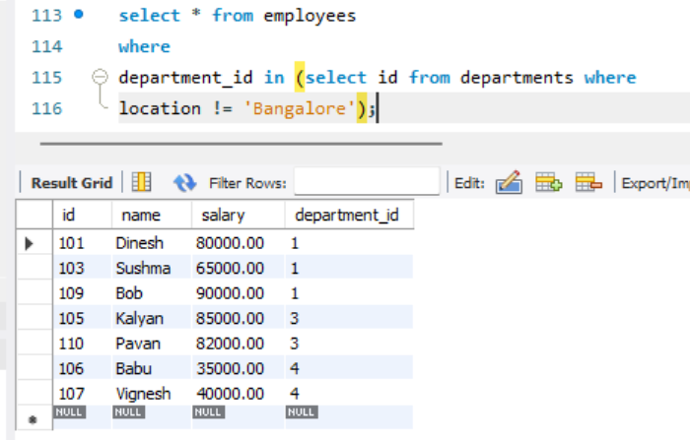

19.
Display employees belonging to departments with IDs less than 3.
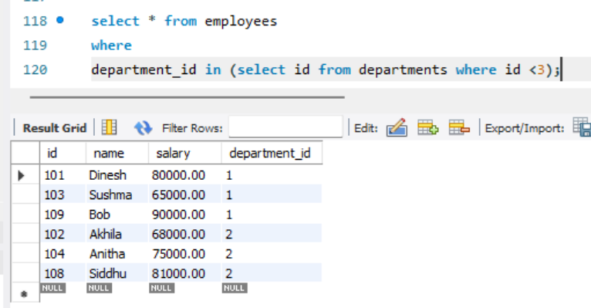

20.
Display employees belonging to all departments located in Hyderabad.
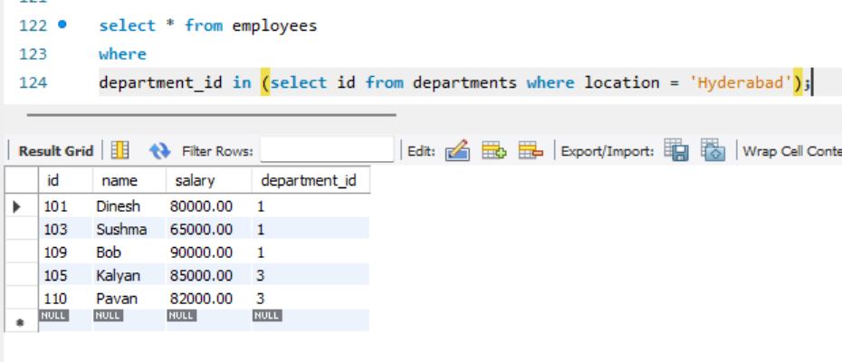

Challenge Question
Try replacing IN with = in one of the above queries.
Observe the error and explain why it occurs.
0 | 19 | 17:49:35 | select * from employees where department_id = (select id from departments where location = 'Hyderabad') LIMIT 0, 1000 | Error Code: 1242. Subquery returns more than 1 row | 0.000 sec

Section C – Correlated Subqueries
Use only Correlated Subqueries.

21.
Display employees earning more than the average salary of their own department.
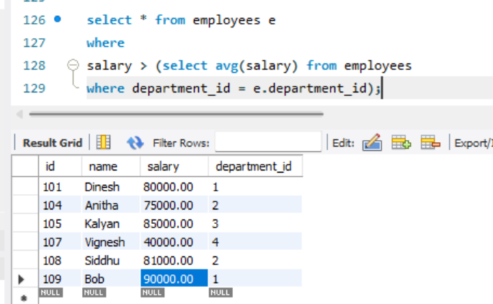

22.
Display the highest paid employee from each department.
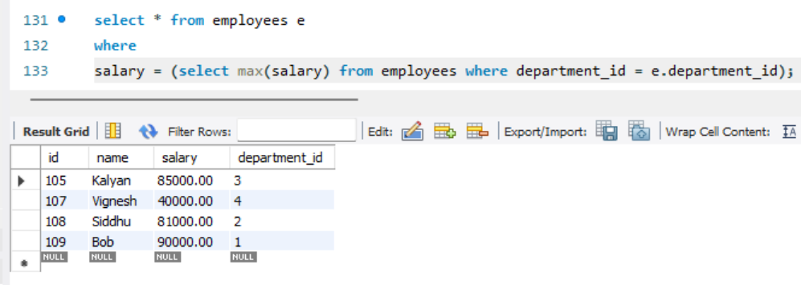

23.
Display the lowest paid employee from each department.
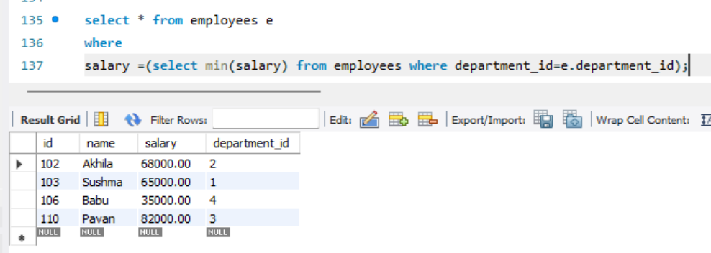

24.
Display employees earning exactly the average salary of their department.
Observe the output.
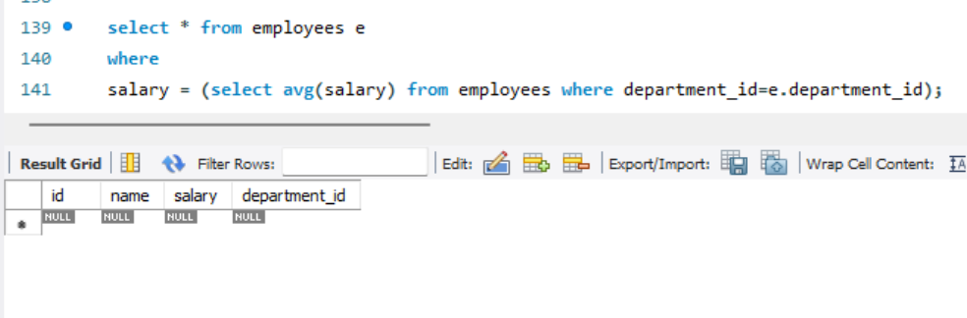

25.
Display employees earning above their department average but below the company average.
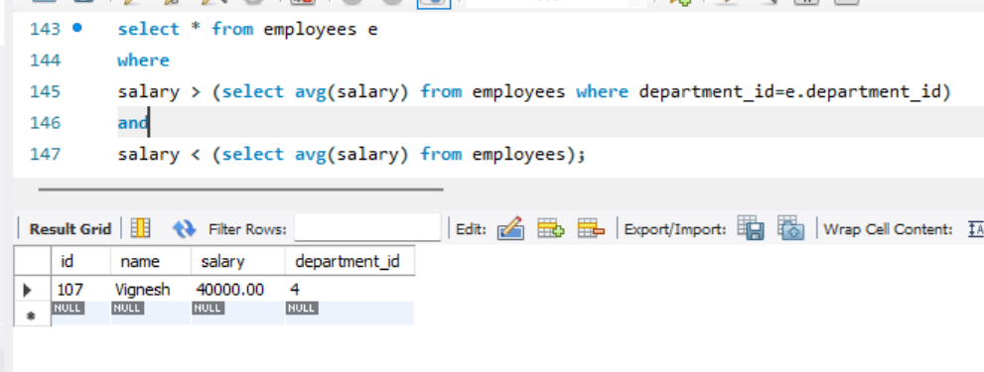

26.
Display employees earning below their department average.
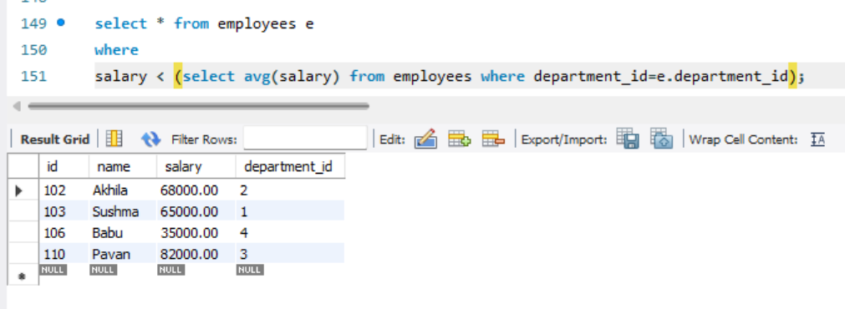

27.
Display employees whose salary is equal to the maximum salary in their department.
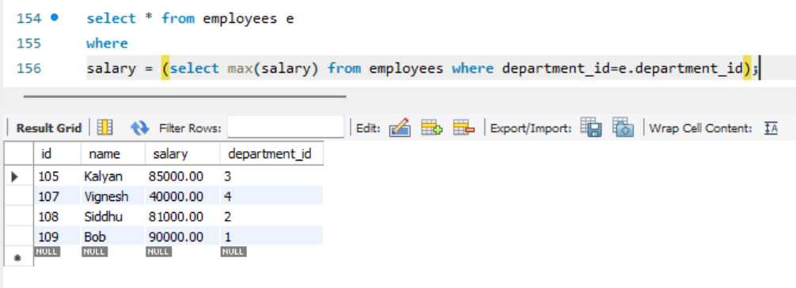

28.
Display employees whose salary is equal to the minimum salary in their department.
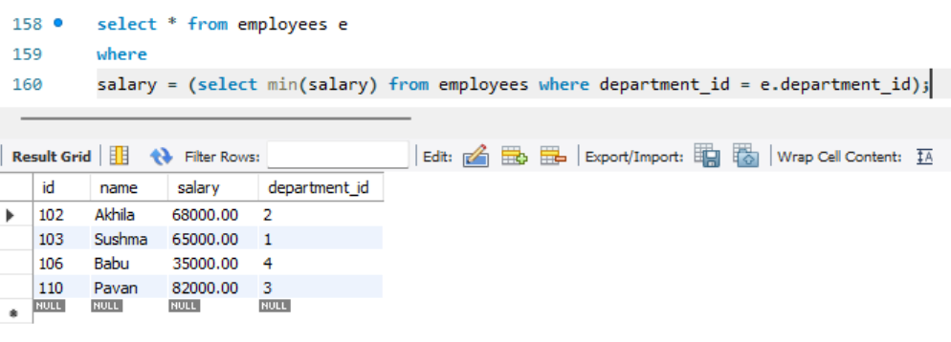

29.
Display employees whose salary is greater than every other employee in their own department.
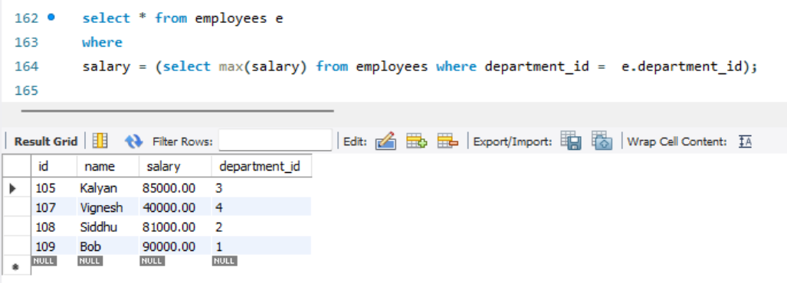

30.
Display employees whose salary is less than every other employee in their own department.
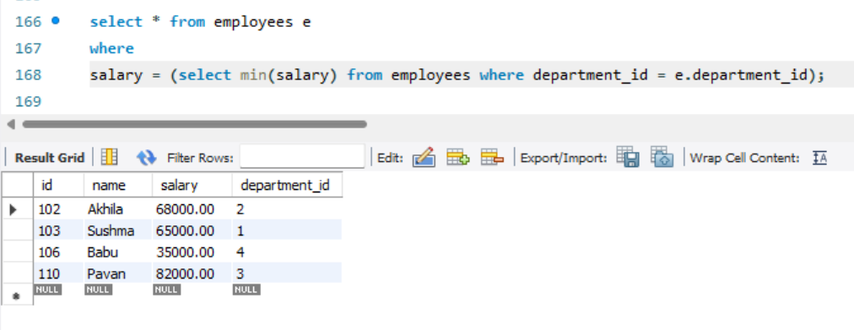

All queries
create database TechNova_solutions;
use technova_solutions;
create table departments(
id int primary key,
department_name varchar(50),
location varchar(50));

create table employees(
id int primary key,
name varchar(50),
salary decimal(10,2),
department_id int,
foreign key(department_id) references departments(id)
);

insert into departments values
(1,'Engineering','Hyderabad'),
(2,'Sales','Bangalore'),
(3,'HR','Hyderabad'),
(4,'Finance','Chennai')
;

insert into employees values
(101,'Dinesh',80000,1),
(102,'Akhila',68000,2),
(103,'Sushma',65000,1),
(104,'Anitha',75000,2),
(105,'Kalyan',85000,3),
(106,'Babu',35000,4),
(107,'Vignesh',40000,4),
(108,'Siddhu',81000,2),
(109,'Bob',90000,1),
(110,'Pavan',82000,3)
;

select * from employees;

select* from employees
where
salary > (select avg(salary) from employees);

select * from employees
where
salary = (select max(salary) from employees);

select * from employees
where
salary = (select min(salary) from employees);

select * from employees
where
salary > (select min(salary) from employees);

select * from employees
where
salary < (select max(salary) from employees);

select * from employees
where
salary=(select avg(salary) from employees);

select * from employees
where
salary>(select avg(salary) from employees) and salary < (select max(salary) from employees);

select * from employees
where
salary < (select avg(salary) from employees) and salary > (select min(salary) from employees);

select * from employees
where
salary=(select max(salary) from employees);

select * from employees
where
salary=(select min(salary) from employees);

select * from employees
where
department_id in (select id from departments where location='Hyderabad');

select * from employees
where
department_id in (select id from departments where location = 'Bangalore');

select * from employees
where
department_id = (select id from departments where location = 'Chennai');

select * from employees
where
department_id in (select id from departments
where
department_name='Engineering' or department_name='Sales');

select * from employees
where
department_id in (select id from departments where id > 2);

select * from employees
where
department_id in (select id from departments
where location ='Hyderabad' or location='Chennai');

select * from employees
where
department_id in (select id from departments where department_name like 's%');

select * from employees
where
department_id in (select id from departments where
location != 'Bangalore');

select * from employees
where
department_id in (select id from departments where id <3);

select * from employees
where
department_id in (select id from departments where location = 'Hyderabad');

select * from employees e
where
salary > (select avg(salary) from employees
where department_id = e.department_id);

select * from employees e
where
salary = (select max(salary) from employees where department_id = e.department_id);

select * from employees e
where
salary =(select min(salary) from employees where department_id=e.department_id);

select * from employees e
where
salary = (select avg(salary) from employees where department_id=e.department_id);

select * from employees e
where
salary > (select avg(salary) from employees where department_id=e.department_id)
and
salary < (select avg(salary) from employees);

select * from employees e
where
salary < (select avg(salary) from employees where department_id=e.department_id);

select * from employees e
where
salary = (select max(salary) from employees where department_id=e.department_id);

select * from employees e
where
salary = (select min(salary) from employees where department_id = e.department_id);

select * from employees e
where
salary = (select max(salary) from employees where department_id = e.department_id);

select * from employees e
where
salary = (select min(salary) from employees where department_id = e.department_id);

